CHILDREN FIRST: PVO 143/23

**Inspiring Hope and Loving Service to Children**

**Founded:** **2021**

**Contact Us!**

**Physical Address:**  **26 Tongogara Street, Rusape, Zimbabwe**

**(Currently domiciled at 760 Castle Base, Rusape)**

**Hours: Open 0800 Closes 1700 hours**

**Phone: +263 252051228**

**Mobile: +263 784816692/781629652**

**WhatsApp: +263781629652**

**E-Mail childrenfirst018@gmail.com**

**Website: to be advised**

**Facebook: to be advised**

**Twitter: to be advised**

**About Us Overview**

Children First, acronym (CF), is a newly- founded, Christian, inclusive, non-profit children-centered, human development organization. It is registered under Zimbabwe Government Private Voluntary Organization Act, Chapter 17.05. The organization aims at addressing child rights priorities and sustainable development goals (SDGs) by improving the quality of life of orphans and other vulnerable children. Children First works to see reduction of cases of violence against children, child sex work, child marriages, drugs, school drop outs, poverty, restoration of dignity, provision of healthcare and SRHR information, nutrition, clean water, education, particularly, girls` education, disability inclusion and referrals for treatment of mental illnesses. The organization advocates for opportunity and protection, loving caregivers and support for environmentally sustainable economic strengthening activities for most vulnerable children to ensure safe, nutritious and sufficient food all year round. Children First (CF) targets infants and children aged (0-5), young teens (6-14) and youth (15-24).

**Our History**

Children First was mooted in 2021 with the aim of providing community solutions to a needs assessment survey that was conducted by Makoni District Department of Social Welfare in 2019. The survey found out that orphans and other vulnerable children in Makoni District faced challenges of access to quality education, fragrant child rights abuses in the communities, lack of nutrition, access to health information, lack of assistive technologies, child marriages, people trapped in traditional thought and practices that put children`s life at risk of death from preventable causes, HIV infection, dropping out of school, violence, poverty, disease, hunger child labour and malnutrition. Children First is motivated by the desire to achieve lasting change for children.

**Where We Work**

Children First is currently working in Makoni District, Manicaland Province, but intends to expand its geographical coverage to include Hwedza, Murehwa and Goromonzi Districts of Mashonaland East. It started by collaborating with Spina Bifida and Hydrocephalus Association of Zimbabwe (SHAZ) in 2021 by making referrals of children in need of surgery and treatment. In Makoni West, it is working with volunteer community child care workers and facilitators in raising awareness of children`s needs and the importance of making referrals to service providers.

**Our Strategic Plan for 2024-2028**

Our 2024-2028 strategy is a product of consultation with our members, staff, board, stakeholders and communities and an analysis of current challenges for orphans and other vulnerable children in our communities. These constitute our compass to our promising future and focus on:

* Upholding the right to quality education and defending children whose rights are violated
* Mobilize legal assistance for victims of children`s rights violations
* Upholding and advocating for improvement and fulfillment of child rights and their attendant environmental rights
* Upholding the right of children to better health, ASRHR information, clean water and sanitation and preventing HIV infection, malaria, diarrhea
* Support and make treatment referrals for children with mental illnesses and other disabilities
* Upholding the right to environmentally sustainable, resilient livelihoods projects to help children, and decent jobs and entrepreneurship for post adolescents
* Support children with emergency assistance during sudden onset of natural disasters
* Increasing efforts to diversify fundraising to support our development work sustainably

**Our Impact**

This has been achieved through raising community awareness aimed at improving the education, health, livelihoods, and child rights of children in the communities that we serve in Makoni District.

**Our Vision**

Towards an empowered community with a civilization of commitment to rights of children

**Our Mission**

To serve vulnerable children and promote care and justice for them

**Our Values:**

Service, Humility, Inclusion, Transparency, Accountability, Love of Christ and neighbour

**Our Goal**

Improving the quality of life for orphans and other vulnerable children

**Our Objectives**

Our work is premised on three strategic objectives below**:**

* To provide educational support to orphans and other vulnerable children
* To advocate for rights of children
* To facilitate economic strengthening activities for orphans and other vulnerable children

**Board Chair`s Governance Statement**

Children First (C.F.),has an executive committee of seven members who have varied backgrounds and technical experience. These are drawn from different sectors: health, education, law and order, banking, church, justice and finance. Our work is founded on a commitment to promote orphans and other vulnerable children`s right to education, health, protection and livelihoods. We complement government`s efforts in preventing children from HIV/AIDS and gender based violence, harmful substances, sexual abuse, child marriages, exploitation, physical and emotional abuse and maltreatment.

Children First **(**C.F.) board members have oversight over sub committees of finance, programs and human resources to ensure sound stewardship of resources to reach their intended rights holders. As a board of directors, we make sure that management take a pledge of integrity and uphold the highest ethical standards and fully comply with Children First`s financial regulations to ensure transparency and implementation fidelity of projects. Children First cherishes shared values and objectives, agreed project strategies and clear roles and responsibilities with funding partners. Children First strictly complies with funders strategic operating procedures.

Furthermore, Children First believes strongly that children have a right to food and medical care. Children as rights holders have a right to have their voices and concerns heard, and they have a right to quality education, that helps them to discover their own potential and develop it. Children First strives to be a trusted partner for children and youth living in poverty by adopting the child rights approach. The approach regards children as individuals with their own personalities and need to participate in important decisions that affect them. Children First is committed to working towards a future that is free from destitution, violence and abuse by advocating and lobbying for elimination of grave children`s rights violations by mobilizing communities through addressing socio-cultural and religious factors that increase risk of child abuse and HIV infection.

Wonder Stan Nyabereka -**Board Chairperson**

**Our Board**

Children First is guided by a board of directors who assist with oversight in matters of governance, organizational issues, policy development and strategy among other roles. We pledge to treat all our funders with respect, honesty and openness. We pledge to be accountable and transparent so that benefactors and prospective donors can have full confidence in Children First. We pledge that we will efficiently and effectively apply all gifts donated to our organization for their intended purposes. Our Executive Committeeis made up of seven serving members as per requirements of the PVO Act Chapter 17.05. Their profiles are as follows:

**Mr. Wonder Stan Nyabereka**

**Board Chairperson**

He has over the years been an active volunteer with Barclays Bank and within various communities around Zimbabwe, reaching out to vulnerable community members and children. He also participated in community outreach activities for children in Zambia and South Africa. Mr. W.S. Nyabereka is 59 and holds an MBA degree in Leadership and Sustainability Research on Banking and Technology of the Future conferred by University of Cumbria – UK. He holds Information Systems Examinations Board ITIL Certification – 2002 City & Guilds London Certifications in Applied Information Technology – 1999. His employment history include 30 years stint at Barclays Bank of Zimbabwe Limited where he rose to the position of Chief Operating Officer. Mr. Nyabereka worked in other countries: Botswana, South Africa, The United Kingdom and Caribbean Islands as a ‘secondee’ on projects and formal assignments. He was Regional Head of Technology Southern Africa and the Mediterranean from July 2004 to December 2006. The scope of his duties as Chief Operating Officer included the direction and oversight of the general Operations and Technology functions that among other things included fraud/forensics and security management, Information Risk Management, Financial Crime Management, Governance and Control: Other engagements included ZIMSWITCH Holdings Board Chairman, ZIMSWITCH Technologies Board Chairman – November 2018 to date, Revival Technologies General Manager – January 2021 to date. Mr. Nyabereka is a non-Executive Director of OK Zimbabwe. He brings a wealth of experience in financial oversight and stewardship of resources at Children First.

**Sr. Edina Anuarite Manyahi (Carmelite Sisters)**

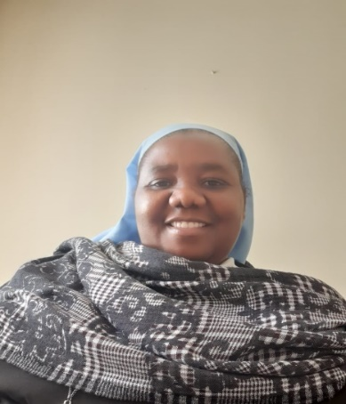**Vice- Chairperson:**

Sr. Edina Anuarite Manyahi is a Carmelite Sister of the Roman Catholic Church and is 51 years of age. She has vast experience in health and pastoral work. She was Nurse- in-Charge of St. Michael Catholic Mission Hospital in Makoni District Zimbabwe for 10 years. She was also the District Volunteer Coordinator for Diocese of Mutare Community Care Programme for an Orphan Care and HIV & AIDS- Home Based Care Project during that stint. She has been the Diocese of Mutare Health Coordinator for 10 Catholic Mission Hospitals in Manicaland. She is currently the Family Apostolate Secretary for Family and Marriages Commission at The Zimbabwe Catholic Bishops Conference. She holds aMaster of Science Degree in Marriage and Family Sciences from John Paul 11 Pontifical Theological Institute for Studies On Marriage and Family, India and graduated in 2019. She also holds a Diploma in Resource Mobilization and Project Management, Regional Partnership for Resource Development from Commonwealth University obtained in 2015, Certificate-Accredited Teacher of Billings Ovulation Method, WOOMB International Limited, Australia, 2014, Bachelor of Nursing Science Degree, Zimbabwe Open University, Harare, 2007, Diploma in Nursing, Parirenyatwa Group of Hospitals, Harare, Zimbabwe, 1999 and a Special Honours Bachelor degree in Monitoring and Evaluation with Lupane State University. She has vast experience of addressing key issues that affect families and children in particular. She is a great influence in the programming of the organization in assisting families and vulnerable children in the communities that we serve.

**Mr. Brian Mwaonga**

**Board Treasurer:**



He is 41 and has a passion for Child Protection and Safeguarding. He is a certified Physical Security Manager with (ISO) Swaziland 2021, a holder of a Bachelor of Science Degree in Counseling with Zimbabwe Open University, a Professional Graduate Diploma in Risk and Security Management-(CIRSM 2021), a Certificate in Peace and international conflict resolution (POTI) 2018, Certificate in Preventing Violence Against Women and Gender Inequality In Peacekeeping 2018, a Certificate in Human Rights (POTI) 2017, a Certificate in Principles and Guidelines for UN Peacekeeping Operations (POTI) 2017, a Certificate in International-Humanitarian Law(POTI) 2017, a Certificate in Systemic Counselling in the Context of HIV & AIDS (Connect-Zimbabwe Institute of Systemic Therapy 2014), a Certificate in Community Based work with Children and Youth (University of KwaZulu Natal-South Africa 2014) and a Certificate in Systemic Counselling in the Context of HIV & AIDS (Z.O.U 2014). His work experience includes 18 years as a Police Officer with Zimbabwe Republic Police doing investigations and counseling of victims of sexual abuse, domestic violence and HIV and AIDs. From 2017 to date, has held the position of Officer in- Charge Operations for Rusape District Headquarters. Mr. Brian Mwaonga was Member- in- Charge Rusape District Victim Friendly Unit section responsible for all sexual crime management and investigation in the district with 12 operational stations. His achievements included being awarded a certificate of best recruit at Morris Training Depot in 2003, a Memorandum of good work performed for compiling station Victim Friendly Unit reports at District level -2011. Being a police officer, he can be trusted with oversight over the funds of the organization as he is fully aware of laws and the rules that govern safe keeping of organizational funds.

**Mr. Shepherd, Tendai, Richard Kureya**

**Board Secretary:**

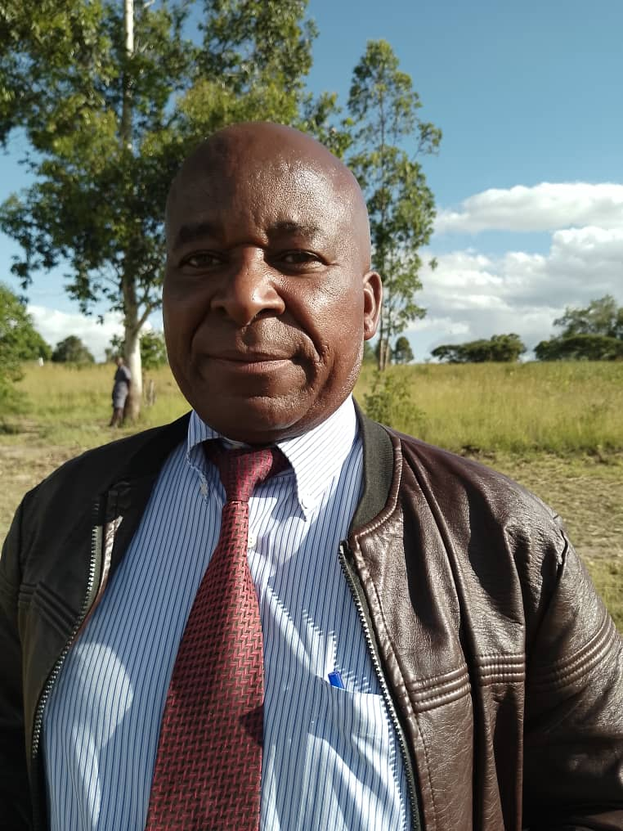

Mr. Shepherd Kureya is 61 years old and currently a school head at St. Faith Inclusive Primary School in Makoni District which. He holds a Certificate in Education Primary and a Certificate in Special Education-all from University of Zimbabwe and, he holds also a Bachelor of Social Science in Low Vision Therapy from Stockholm University, Sweden. As he is working with children in an inclusive school, he has greater understanding of children needs. Mr. Kureya is of great assistance on how to include children with disabilities in the programs of Children First and he advises with the kind of assistance that the children require.

**Ms. Priscilla Rasara**

**Vice Secretary:**



Priscilla Rasara is a young lady aged 31 years and is employed by the Ministry of

Health as administrator. She has experience in administration issues as she has

been working as an administrator for more than 5 years. She gives hands on

administration issues to the organization. Ms. Priscilla Rasara holds a Bachelor of

Administration Honours degree from University of Zimbabwe. She also holds a

Certificate in Applied Behaviour Analysis from Dubai National Academy, UAE.

**Dr. Oscar Nyaungwa PhD**

**Committee Member 1.**

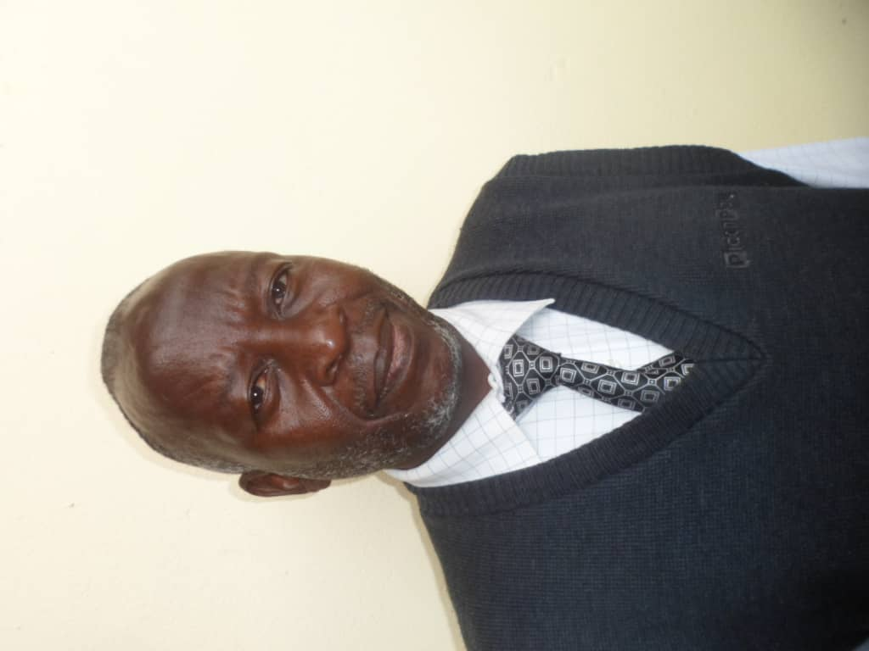

Dr. Oscar Nyaungwa is 63, was born and bred in the District of Makoni. He has a teaching background and has been in the profession and as school head since 1986. He holds a Certificate in Education Primary, a Bachelor of Arts degree, a Master of Arts degree and a Doctor of Literature and Philosophy degree from University of South Africa. He is currently a Schools Inspector in Makoni District. With his experience of more than 30 years working with children and communities, he is a valuable resource person who assists with advice in the smooth- running of Children First Zimbabwe.

**Committee Member 2:**

**Ms. Lois Munyawarara**

She is a female aged 57 years and has background in education and specialized in children with special needs. She is currently working in the Ministry of Primary and Secondary Education at Makoni District offices as a Schools’ psychological services officer. Her work with children with disabilities will definitely have a positive influence in the running of Children First programmes.

**Advisor on Children Treatment Needs**

**Dr. Walter Mutindori**

Dr. Walter Mutindori 44 is Child First Technical advisor on issues of treatment support for sick children. A medical doctor by profession, Walter has passion for children health. He was Centre Manager for Premier Medical Centre in Rusape. He is currently the Managing Director for Dr. Mutindori Family Surgery in Rusape. He holds a Bachelor of Medicine & Surgery degree and a Master of Business Administration degree all from University of Zimbabwe.

**Our Management Team**

The Children First team combines a commitment to supporting vulnerable children and

communities with deep professionalism and long experience in compassionate work. Meet the

team who work to empower most vulnerable children achieve a better quality life.

**Mr. Fanuel Mark Nyatsuro**

**Executive Director**

Bottom of Form

[**DNATE**](https://www.miseancara.ie/donate/)



Mr. Fanuel Mark Nyatsuro aged 59 is passionate about children with disability inclusion, child welfare, children`s rights and child protection. He is the Director of Children First Zimbabwe and reports to the Executive board. He has worked in development work for 19 years. He is also an educationist and has taught in high schools for 13 years. He was programme manager at Diocese of Mutare for 16 years where he contributed in designing, implementing and evaluating impactful child protection and safeguarding, education, health, child rights advocacy and economic strengthening projects that were funded by several donors, i.e., CRS, Project Support, Pact America, USAID through FHI360, Misean Cara, Irish Aid, Porticus Netherlands, Raskob Foundation, Hilton Foundation, among others. He also contributed immensely in fund raising for the organization. With the collaboration of CRS and the Catholic Curia of Mutare Diocese, he crafted the first Child Protection Policy for Diocese of Mutare in 2010. His latest position was Grants Writer Manager at Spina Bifida & Hydrocephalus Association of Zimbabwe. Fanuel holds a Certificate in Education, (English & History) and a B.Ed. degree in Educational Administration, Planning and Policy Studies from University of Zimbabwe, an Executive MBA degree from Africa University, a MSc. degree in Development Studies from Women`s University in Africa, an M.Ed. degree in Educational Management from Zimbabwe Open University and a Diploma in Personnel Management. Fanuel brings a strong track record of hard work and designing and implementing impactful programmes for children in-need and their families.

**Mr. Paul Munyaradzi Mugoni**

**Senior Finance and Operations Manager**

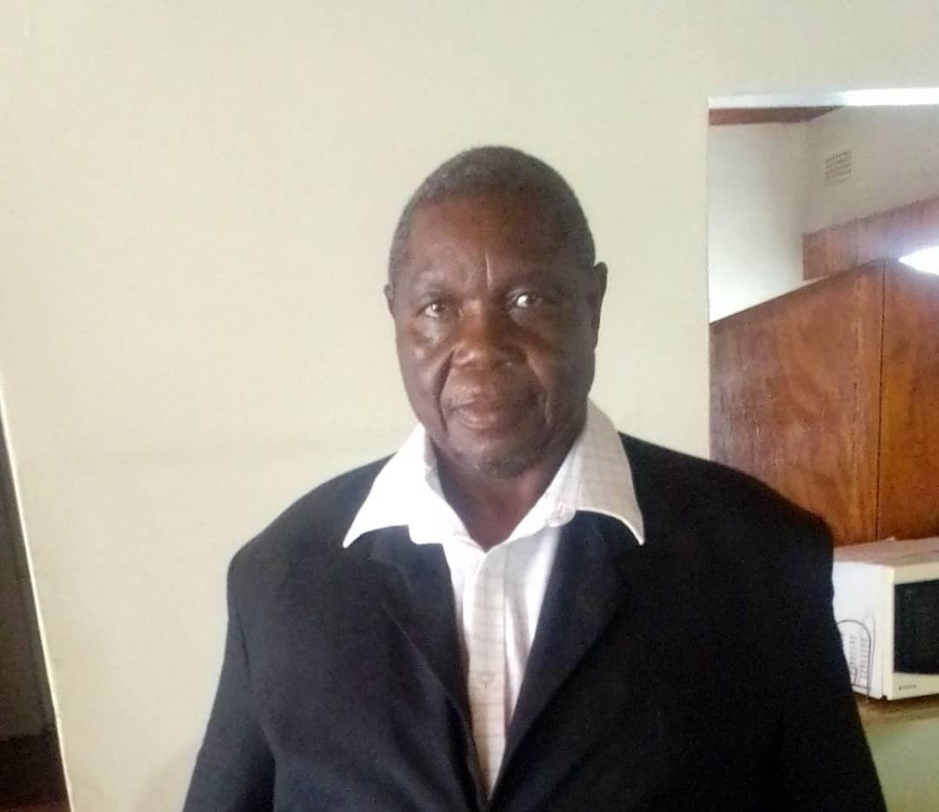

Mr. Paul Munyaradzi Mugoni is a senior member of the management team. He considers integrity and good ethical behaviour as guiding principles. He is the face of the organization on financial matters. Paul reports to the Executive Director and advises the board and the Executive Director on operational and financial matters. He also reports to the Financial Oversight, Risk and Audit Committee of the Executive Board on all matters financial and risk-related. As financial and operations controller, Paul is responsible for managing all donor funds, and provides leadership and direction to the finance and programmes teams and he participates in fundraising for the organization. He oversees implementation of the finance policy, procedures, accounting controls and programming strategic operations procedures. Positions Paul has held over the years include Articled Clerk/Senior Auditor at KPMG Chartered Accountants, Program Accountant at GTZ, Internal Audit at Hippo Valley, Senior Contracts and Finance Manager at GTZ Mozambique, Finance and Administration Director at Diocese of Mutare, Finance and Administration Manager at Wattle Company Limited, Administration and Finance Director, Family Aids Caring Trust (FACT), Country Administrator, International Crops Research Institute for the Semi-Arid Tropics (ICRISAT). He has lectured on a part-time basis in Accountancy at Africa University. Mr. Paul Munyaradzi Mugoni holds a Diploma in Accountancy from University of Zimbabwe, ACIS from Institute of Chartered Secretaries and Administrators and an MBA from Africa University. He has managed donor supported projects for GTZ, EU, USAID, Tear Netherlands, PACT and other major western countries. He comes to Children First from an extensive career in Finance and Accounting in both NGO and private sector.

**Mr. Gift Makotsi**

**Monitoring, Evaluation, Research and Learning Manager**

Gift Makotsi, 38 years of age, is a vastly experienced all-rounder, humanitarian and development work practitioner with 15 years in-field experience. He has 10 years’ experience working in Child Rights, Gender and Diversity Integration programming. He has broad working experience with institutional donors (UNICEF, WFP, USAID, UKAID, ECHO). He is proficient in the utilization of evolving technological software packages, data analysis, presentation, and report writing skills. He also has practical experience in leading and guiding evaluations, surveys and researches, planning, coordinating, implementing and monitoring projects in line with project theory of change. Gift`s work also includes all aspects of fundraising with a strong focus on strategic development through relationship building. His other task is production of learning briefs based on Children First project evaluations. Mr. Gift N. Makotsi holds a Master of Science degree in International Affairs from Midlands State University and a Bachelor of Social Work Honours degree from University of Zimbabwe. He has worked for GOAL Zimbabwe as a Programme Manager, Government of Zimbabwe Department of Social Development as a Social Welfare Officer, Population Services International as a District Field Manager and Plan International as a Gender and Child Protection Programme Facilitator. As MERL, Fundraising and Communications Manager, Gift reports to the Senior Finance and Operations Manager.

**Mrs. Loraine Mugwagwa**

**Programme Manager**

Mrs. Loraine Mugwagwa is 42 years old and holds a Bachelor of Psychology Honours degree from University of Zimbabwe and a Post Graduate Diploma in Social Work from Women University in Africa. She has had 19 years’ stint with Zimbabwe Government Department of Social Development as a Social Worker/Development Officer. She has been head of the Makoni District Social Development Office for 14 years. She has collaborated extensively with development partners in areas of orphans and vulnerable children programming- child rights, child safeguarding and protection, economic strengthening and humanitarian work. Mrs. Loraine Mugwagwa brings to Children First a wealth of experience in child rights and protection. As Programme Manager, Loraine is responsible for implementation and process monitoring of all funded projects. She also participates in fundraising for the organization. The programme Manager reports to the Senior Finance and Operations Manager.

**Ms. Hazel Nyahoda**

**Programme Officer**

Ms. Hazel Nyahoda

Ms. Hazel Nyahoda is 26 years old and holds a Bachelor of Social Work Honours degree from Women University in Africa. She has had 6 years stint with FHI360 as a Supervisor for Adolescent Girls and Young Women HIV and Gender Based Violence Prevention DREAMS Project. She had vast experience in mentoring adolescent girls aged 15-19 in the prevention of HIV infections. As a young person, she has a great deal of appreciation of the drivers of child rights violations in the communities. She collaborated with other organizations and facilitated referrals that enabled the adolescent girls to access SRHR services. Hazel participates in fundraising for the organization and reports to the Programme Manager.

**Ms. Tariro Nyakudyara**

**Finance Intern**

Ms. Tariro Nyakudyara is aged 25 and holds a Bachelor of Science Honours degree in Actuarial Science from University of Zimbabwe where she did courses in Finance, Risk Management and some borrowed courses in Accounting. She has had 6 years stint with FHI360 in partnership with DOMCCP as a Club Facilitator Supervisor for Adolescent Girls and Young Women HIV and Gender Based Violence Prevention DREAMS Project that was funded by USAID. She will be inducted in finance and compliance duties by Children First and its partners. The finance intern reports to the Finance Officer.

**Mr. Rafael R. Sodzayi**

**Finance Officer**

Mr. Rafael R. Sodzayi aged 31, holds a Bachelor of Science Honours degree in Accountancy from Chinhoyi University of Technology, a Master of Accountancy degree from University of Zimbabwe and a Certificate in Applied Behaviour Analysis from National Academy, United Arab Emirates. He is a member of the Association of Chartered Certified Accountants, (ACCA). He has been employed as Accounts Officer at learning institutions. His duties entailed all financial aspects of managing the institutions finances. As Finance Officer, Mr. Rafael R. Sodzayi reports to the Senior Finance & Operations Manager.

**In pictures**

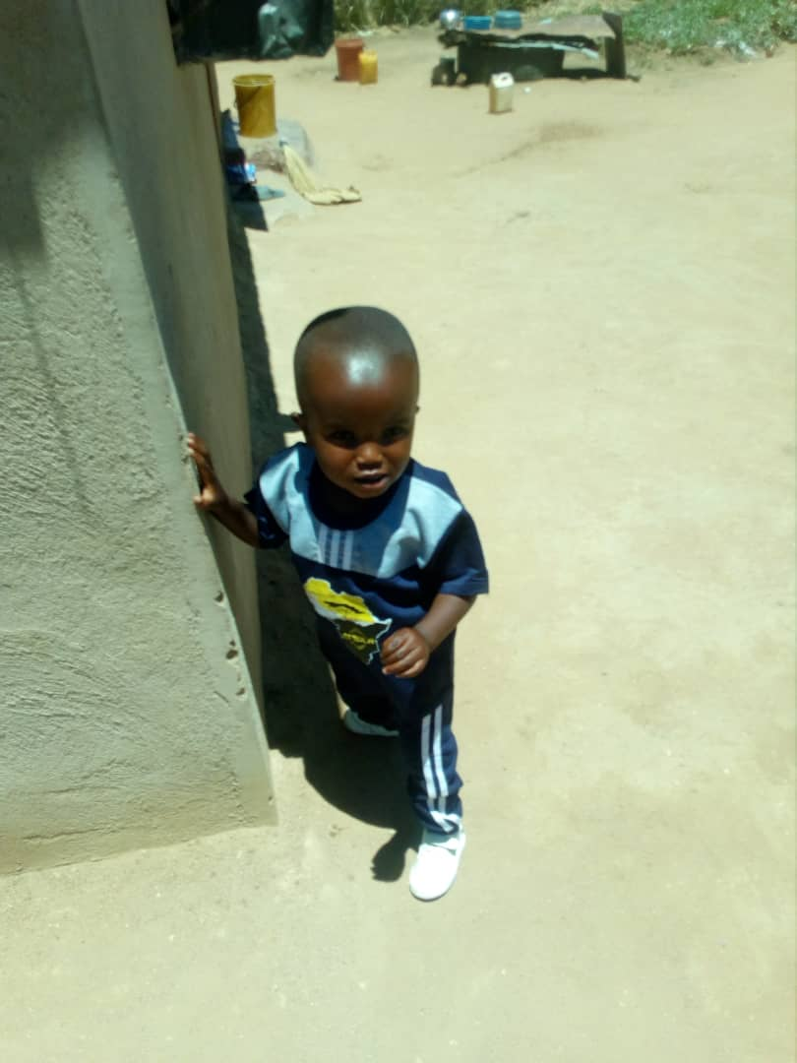

**A child living with hydrocephalus who was referred by Children First for treatment at Spina Bifida & Hydrocephalus Association of Zimbabwe. The child is now starting to walk.**